Landscape evolution and speleogenesis in Gråtådalen valley, Northern Norway.

Terje Solbakk & Stein-Erik Lauritzen

Department of Earth Science,
University of Bergen,
Allègt. 41, N-5007 Bergen, Norway

Abstract
Gråtådalen valley, Svartisen, north Norway is a hanging tributary to a larger valley, where the junction is perched on erosion-resistant schists. Marble bands further up-valley contain numerous caves at various levels above the valley floor. This situation is ideal for testing the possible connection between stages in valley downcutting and corresponding morphological signatures in the caves. The caves are subject to accurate re-surveying, allowing a thorough speleogenetic and speleochronological analysis. This is part of an ongoing master thesis at the University of Bergen, Norway and further details will be given in the oral presentation.

Introduction
The southern part of North Norway; Nordland county, is situated within Caledonian allochtonous rocks containing marble outcrops that has been more or less heavily karstified, classified as the Norwegian stripe karst type (Horn, 1935; Lauritzen 2001). Gråtådalen (66º’N 14º’E) is a tributary valley situated in the Salten area above the Arctic Circle, Figure 1. The valley displays intense karstification in the mid and lower part. There are approximately 70 caves here, described by Corbel (1957, pp175-184), St.Pierre`s (1966), Lauritzen (1983) and others. The valley is generally a glacially sculptured through, but is incised by a smaller fluvial, V-shaped trench along its entire length. , The lower-mid part is an over-deepened basin containing glaci-lacustrine sediments. The fluvially incised valley continues towards the present-day valley outlet. The main valley has several shoulders wchic allude to stages in its erosional history. Several of these shoulders correlate roughly with the position of cave passages.

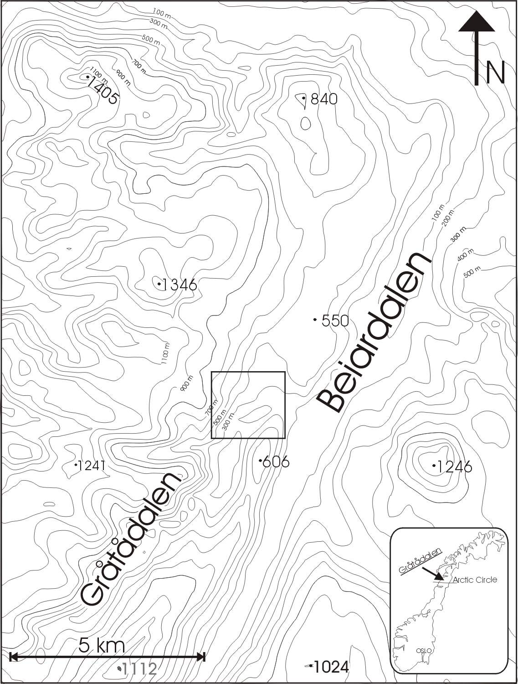 | Figure 1.  Topographic setting of the study area, showing Gråtådalen as a tributary to the larger Beiardalen. Heights in meter. The location at The Arctic Circle is shown in the inset; the square at the valley junction depicts the outline of Figure 2.

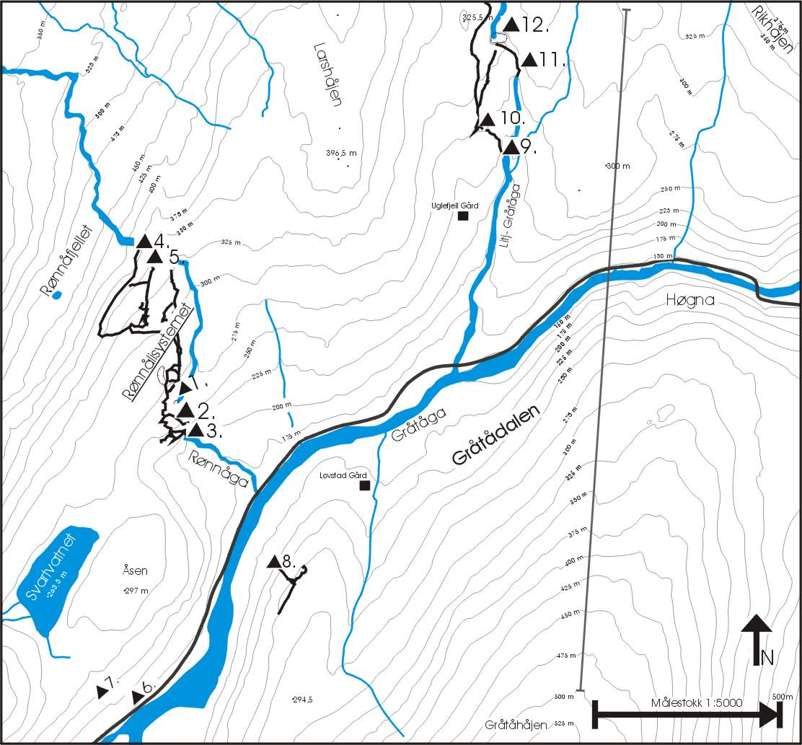 | Figure 2.  The caves of central Gråtådalen, in part after StPierre (1966), Holbye & StPierre (1973) and StPierre 2003. Numbers refer to caves listed in Table 1. Most of these caves will be resurveyed in the present project. The vertical line transect represent the valley cross-section used in Figure 3.

Table 1
Caves of central Gråtådalen, data from previous reports.
No. | cave | length | depth | comments
1 | Øvre Rønnalihøla | 1800 | -110 | Caves 1, 2, 3 are linked
2 | Smith`s Cavern | 1800 | -110
3 | Rønnålihøla | 1800 | -110
4 | Satisfaction Cave | 1000 | 55
5 | Unnamed Cave | 270 | 40
6 | Nedre Svartvassgrotta | 160
7 | Øvre Svartvassgrotta | 800 | -100
8 | Løvstadgrotta | 190
9 | Nedre Stormdalshøl | 50 | 55 | Depth Cave 9 + 10
10 | Øvre Stormdalshøl | 1200 | 55 | Caves 10 and 11 are linked
11 | Jordbruhøla | 1200
12 | Isgrotta | 130

Caves and their topographic setting.
Several valley shoulders in Gråtådalen seem to correlate with the levels of the caves up in the hillsides. The caves are mainly of vadose origin, but with some phreatic elements. Scattered fluvial sediments can be found in several levels within the caves. The change in valley evolution has left behind 10-15 km of the paleic valley further north of the outlet, and can today be seen morphologically as a broad valley shoulder to the main valley of the area. The aim of this study is to test the hypothesis on changing valley outlet by carrying out accurate cave surveying and to use uranium series dating techniques on calcite concretions and speleothems. It is hopefully possible to gain absolute dates and attach those to reveal part of a successive valley evolution history. Recently an investigation carried out by the Geological Survey of Norway (Olesen et al, 2004) showed a probablye neotectonic feature on the eastern ridge adjacent to the valley. The fracture is associated with gravitational spreading and collapse (sackungen) features. We will investigate whether neotectonic activity might have affected the speleogenetic development in adjacent caves.

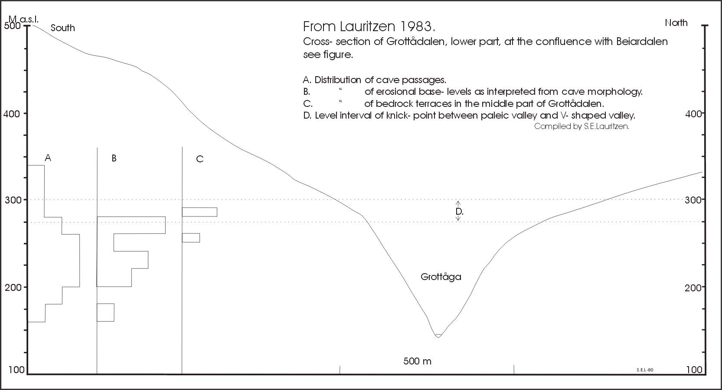
Figure 3.
Compilation of previous data suggests that the cave passages are concentrated at or below the main knick-point of the Gråtådalen valley, after Lauritzen (1983). This knick-point represents the floor of the presumably pre- or early Quaternary, “paleic” valley.

Chronology
Speleothems are extremely rare in the caves, although calcareous concretions and local cementation of glacigenic sediments (Höhlenkrapfe or marl balls, Kyrle 1923) are occationally found. We hope to date such deposits at geomorphologically crucial positions in order to post-date erosion or sedimentation episodes. Previously, a flowstone covering a sand deposit in Løvstadgrotta (No. 8, Figure 2 and Table 1) dated to 9.46 ± 0.46 kyr by Uranium-series dating (α- counting).

Compilation and further work
A previous compilation of the vertical distribution of all data known up to 1983 suggest that speleogenesis may be linked to the development of the younger, V-shaped incision into the paleic Gråtådalen valley, Figure 3. Both the total vertical distribution of caves, ‘probable base-levels’ in the cave surveys and the level of bedrock terraces further upvalley are concentrated at or closely beneath the transition between the two valley profiles. The interpretation of cave morphology from the existing cave maps is dubious, as the caves are basically mapped in the horizontal plane and the quality of mapping is not adequate for morphogenetic interpretation. In order to identify clear mesoscale vadose/ phreatic transitions (e.g. Lauritzen & Lundberg 2000) and rule out possible structural influences, detailed 3D surveying and close inspection is necessary.

References
Corbel, J., 1957; Les Karsts du nord-ouest de l`Europe. Mem. Docums. Inst. Etud. Rhodan. 12, 541 pp.
Holbye, U. & St.Pierre, D. 1972: Caves of the Store Rønåga Gråtådal, Beiarn. End paper, Swetc caving Club Occational Publication No. 3. p 45.
Kyrle, G. 1923: Grundriss der Theorethischen Speläologie. Speläologische Monographien, Bd 1. 353 pp.
Lauritzen, S.E., 1983; Arctic and Alpine Karst Symposium, August 1-15, 1983, Department
of Chemistry, University of Oslo.
Lauritzen, S.E. 2001: Marble stripe karst of the Scandinavian Caledonides: and end-member in the contact karst spectrum. Acta Carsologica 30 (2) 47-79.
Lauritzen, S.E. & Lundberg, J. 2000: Meso- and micromorphology of caves: Solutional and erosional morphology. pp. 408-426 in Klimchouk, A.B.; Ford, D.C.; Palmer, A.N. & Dreybrodt,W. (Eds.) Speleogenesis. Evolution of Karst Aquifers. National Speleological Society, USA, 527 pp.
Olesen, O.; Blikra,L.H.; Braathen,A.; Dehls,J.F.; Olsen,L.; Rise, L.; Roberts, D.; Riis,F.; faleide,J.I. & Anda,E. 2004: Neotectonic deformation in Norway and its implications: a review. Norwegian Journal of Geology, 84, pp 3-34.
St.Pierre, D. and others 1966; The Caves of Graataadalen, Northern Norway. The transactions of
the Cave Research Group of Great Britain. 8 (1), pp. 1-64.
StPierre, D. 2003: Norges lengste og dypeste grotter (Norways longest and deepest caves). Norsk grotteblad (40) pp 3-9.

